 | Geofencing Based Attendance System  Technical Design Document
 | Prepared By / Last Updated By | Reviewed By | Approved By
Name | Josten S Cheeran
Role
Signature
Date

Table of Contents

1.0 Introduction 3
1.1 Purpose of this document 3
1.2 Project overview 3
2.0 Solution Summary 3
2.1 Scope 3
2.2 Assumptions 3
2.3 Dependencies 3
2.4 Risks 3
3.0 Schematic Diagram 3
4.0 System Design 4
4.1 Proposed design 4
4.2 Component inventory 4
5.0 Database Design 4
5.1 Data Model 4
5.2 Tables Structure 4
6.0 Appendices 4
6.1 Glossary 4
6.2 Other 5
7.0 Terms & Conditions 5
8.0 Change Log 5

Introduction

Purpose of this document
The purpose of this document is to document the technical design, component details and Database design. This will also capture the scope, assumptions, risk, dependencies of this project.

Project overview
GeoTrack is a modern web-based attendance tracking system that uses geolocation to verify and record employee attendance. The system is built using .NET Core and follows a multi-layer architecture.

Solution Summary

Scope
- Implementation of geolocation-based attendance tracking system
- Development of web-based interface for attendance management
- Integration of geofencing capabilities for location validation
- User management system with role-based access control
- Attendance history and reporting functionality
- Real-time location tracking and verification
- Mobile-responsive web interface

Assumptions
- Users have devices with GPS capabilities
- Stable internet connection is available at attendance locations
- Users have modern web browsers supporting geolocation API
- SQL Server is available for database operations
- Organization has defined geofence boundaries for valid attendance areas

Dependencies
- .NET Core Framework (Latest Version)
- SQL Server Database
- Entity Framework Core
- JWT Authentication System
- NetTopologySuite for Spatial Data
- Modern Web Browser Support
- ASP.NET Core MVC
- HTTP Client Factory

Risks
- GPS spoofing attempts
- Network connectivity issues affecting real-time tracking
- Database performance under heavy load
- Privacy concerns with location tracking
- System availability during peak attendance hours
- Data security and compliance requirements

Schematic Diagram
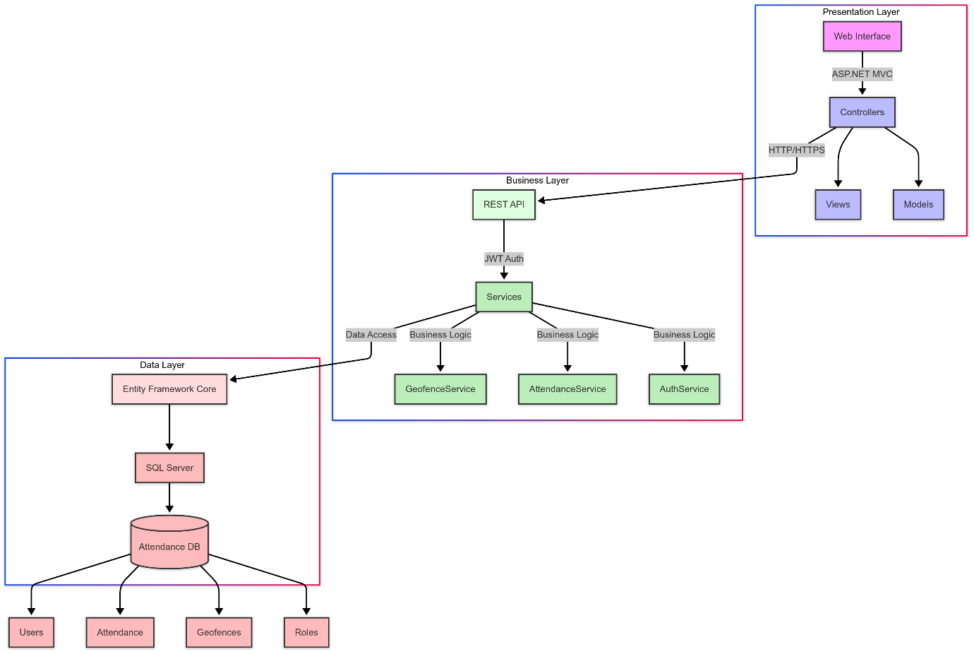

System Design

Proposed design
The system follows a three-tier architecture:
- Presentation Layer (GeoAttendance.Web)
  - MVC-based web interface
  - Responsive design
  - Client-side validation
  - Location services integration
- Business Layer (GeoAttendance.API)
  - RESTful API services
  - Authentication/Authorization
  - Geofencing logic
  - Business rules implementation
- Data Layer (GeoAttendance.Common)
  - Entity Framework Core
  - SQL Server database
  - Data models and repositories
  - Spatial data handling

Component inventory
1. Core Components
- AttendanceService
- GeofenceService
- AuthService
- UserManager
- LocationValidator

2. Supporting Components
- JWT Token Handler
- Error Logger
- API Documentation (Swagger)
- Database Migration Manager

Database Design

Data Model
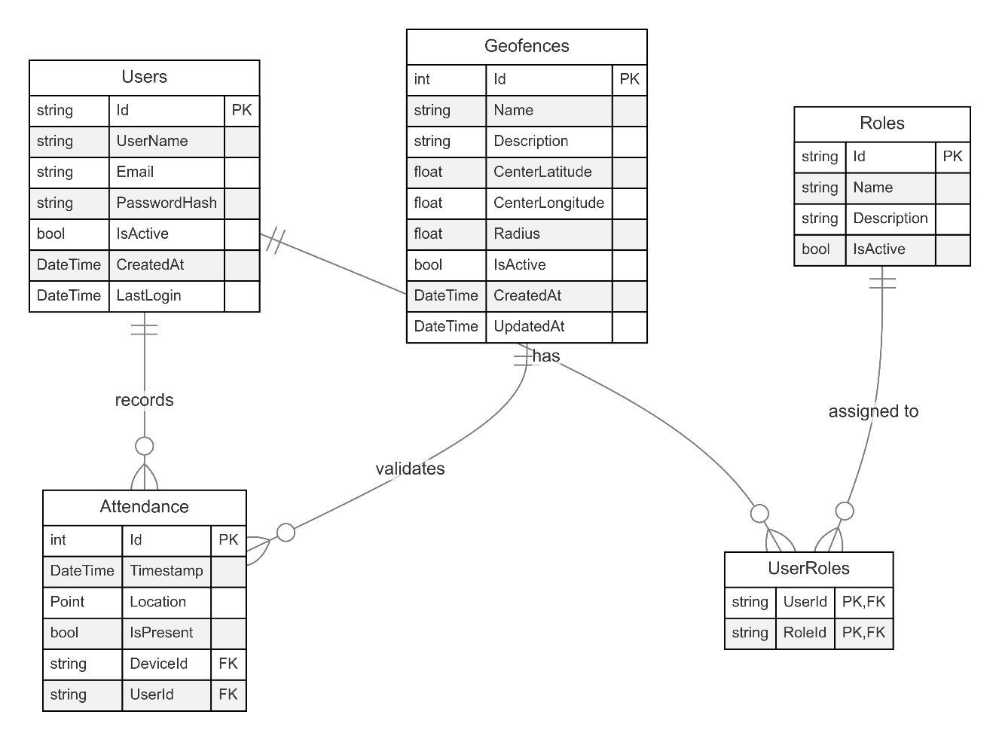

Tables Structure
1.Attendance
Column Name | Data Type | Length | Nulls
Id | Int | 4 | No
TimeStamp | DateTime | 8 | No
Latitude | Float | 4 | No
Longitude | Float | 4 | No
IsPresent | bit | 1 | No
DeviceID | int | 10 | No
UserID | int | 10 | No

2.Geofence Table
Column Name | Data Type | Length | Nulls
Id | int | 4 | No
Name | nvarchar | 100 | No
Description | nvarchar | 200 | Yes
CenterLatitude | float | 8 | No
CenterLongitude | float | 8 | No
Radius | float | 8 | No
IsActive | bit | 1 | No
CreatedAt | datetime | 8 | No
UpdatedAt | datetime | 8 | Yes

Appendices

Glossary
Acronyms | Definitions
JWT | JSON Web Token
API | Application Programmable Interface
MVC | Model View Controller
CORS | Cross Origin Resource Sharing
ORM | Object Relational Mapping

Terms & Conditions
Disclaimer: Please do not circulate or distribute this document outside of Cognizant Network, We have a Zero Tolerance Policy. Kindly adhere to 100% Compliance at all times.

Change Log
Please note that this table needs to be maintained even if a Configuration Management tool is used.
- Version Number | - Changes made
V 1.0 | <If the change details are not explicitly documented in the table below, reference should be provided here>
 | Page no | Changed by | Effective date | Changes effected
 | All | Josten S Cheeran | 13/03/2025 | Initial Document Creation

